Freight Bill Auditing
Freight bill auditing is a two-step process. First, approving fees that need approval and then running the audit process in the AP Freight Bill Audit Approval page. However, following your fee approval, the system will automatically trigger the audit process, if invoices pass audit it will automatically clear, thus saving users time. If the audit fails, these transactions will show up in M status and need to be fixed.
The Fee Approval page (Under Load Planning) allows users to review fees entered into the portal by carriers or via EDI and require approval for auditing purposes. Fee tolerances can be assigned to each fee and approval automation can be configured. See Carrier Page for Fee Tolerances set up.
Assuming freight bills have been entered by carriers via the portal or EDI, here are the steps to process and audit freight bills.
Freight bills will come in on a daily or random basis from carriers. It is important to create a standard process as to how often you will tend to transactions that need approval and managing the exceptions. Freight bills will not be sent to the ERP system unless they have successfully passed the audit routine in TMS (AA status). All transactions must end up in AA status (Approved) in order to be sent to the ERP accounting system.

Step 1 - Go to Fee Approval Page

Each implementation can have a different configuration based on automation of the fee approval process. Some fees will be auto approved, and others will require the attention of a TMS user to review/edit/approve the fee values. This automation configuration and tolerances can be viewed in the Carrier Page under each carrier in the Accessorials tab.
Select a carrier or show all carriers to review each carriers’ fees needing approval.
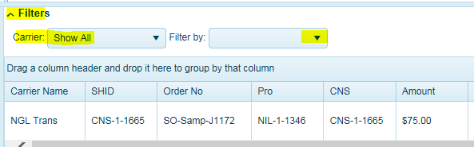
The system will return all transactions for selected carrier-NGL Trans. This example is where a carrier inserted a Tarp Fee at time of invoicing and but was not included during the tendered ($0) process.
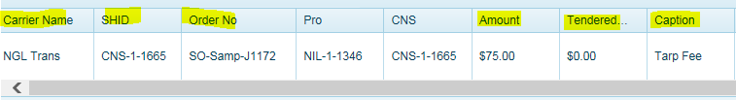
It will display the SHID (ShipID=CNS number or specific carrier assigned Pro Number)
Order Number = shippers order number
Pro Number = unique number assigned by TMS and not the same as carrier assigned pro number.
CNS Number = unique number assigned by TMS and can be the ShipID if no carrier assigned Pro Number is assigned.
Amount = Amount the carrier inserted or EDI fee received.
Tendered = is the value (cost) that was tendered (pre-assigned).
Caption = Fee name

Example of Tendered fee and Fee Amount entered by carrier.
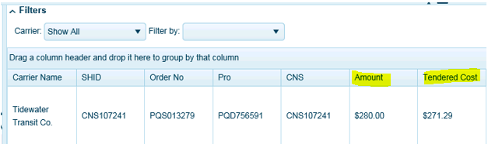
Mod Date = Date entered by carrier or received by EDI.
Dest Name = Ship to location
Lock All Costs = If checked, this was to preserve any costing from being over written. To approve fees, this will need to be unchecked. The system will prompt a message indicating costs are locked. This is typically done on Spot rate or API carrier shipments.
Lock BFC = Same as above if using BFC functionality. BFC stands for Benchmark Freight Cost.
Message = System generated message that will indicate to user why the fee needs approval.

Approve = when users click on Approve, you are agreeing to the amount entered by the carrier. This will update the fee(s) amount in the Revenue Screen and re-calculate and update the carrier cost. Then push this invoice through the audit function.
To Approve Fee = Click APPROVE. 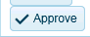
Note, if there are multiple fees for this invoice needing approval, all fees will need to be approved before it will be sent through the audit process. Each fee is processed separately.

Edit = User is modifying the carrier fee entry and is approving the lessor or higher amount entered by the carrier. This will update the fee(s) amount in the Revenue Screen and re-calculate the carrier cost. Then push this invoice through the audit function.

To Edit Fee click EDIT.
Insert approved fee value, click save.
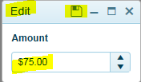
Click APPROVE.

This approval process must be done for each carrier.

Missing Fee Approval Set Up
When a fee comes into TMS for the first time via EDI or if it has not been configured as part of the carrier’s fee tolerance settings, users can configure the fee for automation so the next time this fee comes in, it will follow the business rules for automation and approval. Carriers who are entering invoices into the portal, should contact logistics if you do not see the fee you’re trying to enter. Users should update the carrier configuration for fee to display for carrier. (See Carrier Page-Accessorials)
Click on Add Config.
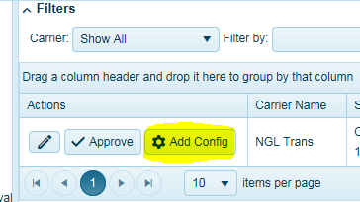
The approval configuration screen will appear for users to configure accordingly.
Auto Approve = Check the box to have this fee auto approve based on tolerance settings. Otherwise, users will need to approve this fee next time if it was not included during dispatch/tender.
Allow Carrier Updates = Check the box to allow carrier edit/updates (via Portal or EDI) Recommended.
Show Contracted Fees = Check the box to display fees during invoice entry (via Portal). Recommended.
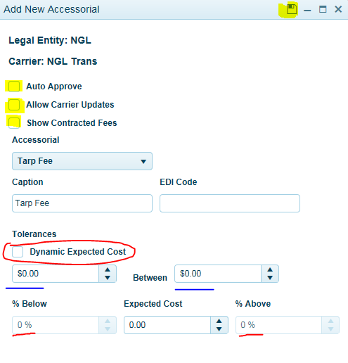
Then select your tolerance settings-
Select only one.
BLUE UNDERLINE -Insert dollar value low and high. For example, $0 (low) between $100 (high). You accept anything between $0 - $100 for this fee. Anything else fails audit tolerance, requires approval.
RED CIRCLE– Check Dynamic Expected Cost to insert a percentage low and high range. For example, 100% (% below) to 25% (% above). Will approve $0 to 25% higher than the cost.

Or
Set your expected cost at $50. Your percentage low set to 20% (which is $50-$10=$40) to 20% above ($50 + $10 = $60) above. This fee expected price range is between $40 - $60. Or just insert expected cost and no low/high range.

Step 2 - Go to AP Freight Bill Audit Approval Page
Select a carrier to review all freight invoices by carrier for a date range (From and To (current date)) that are in various stages of the auditing process. You must select a carrier and invoice received date range. Its best to go back a few months (30, 60, 90 days) to current date to ensure you have all transactions accounted for.

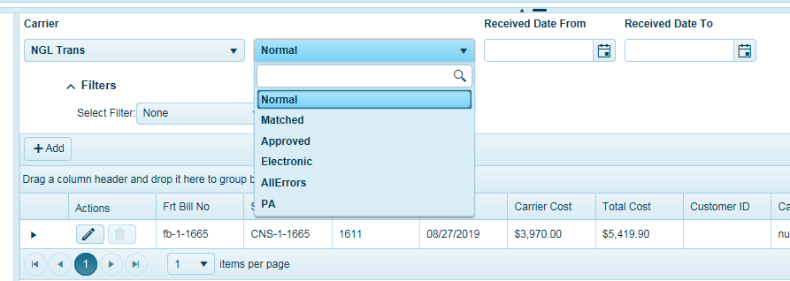

TMS Auditing Workflow:
Normal (N) = Invoices ready to be audited for selected carrier and invoice date range. Note, when filtered by this status, this screen should be blank at all times indicating there are no more transactions for selected carrier and invoice received date range to audit. To audit these transactions, simply click on the Run Audit button in the Actions menu to audit the invoice(s). If the audit passes, invoices will remove from this status and can be reviewed in the Approved status filter. If the audit fails, it will go to M status and requires attention. It is this screen where you re-run the audit manually by clicking the Run Audit Button in the Actions menu. This filter will also show M status transactions to be re-audited.
Matched (M) = Invoices that have matched a transaction in TMS and have failed audit for selected carrier and invoice date range selected. Note, when filtered by this status, this screen should be blank at all times indicating there are no more matched/failed audit transactions for selected carrier and invoice received date range. All transactions in this status will need to be corrected before audit, approval, and sent to the ERP for payment. Users will need to make necessary invoice adjustments and then re-run the audit process while in the Normal filter and clicking Run Audit in the Actions menu.
Approved (AA) = Invoices that have been approved and passed audit.
Electronic = Invoices that have come in via EDI only. Select this to view EDI invoices and in PA or M status.
Pending Approval (PA) = Invoices that have fees waiting to be approved from the fee approval page. The audit process will not run until pending fees have been approved.
NOTE: When Normal (N) and Matched (M) are empty, this means there are no outstanding invoices to be audited for the selected carrier and time period. Users should check PA status on a regular basis for each carrier or go to the Pending Fee Approval Page.
Select carrier and apply invoice received date range. It’s best to review a 30-60-day date range.
Select your workflow = Normal. This will display all transaction statuses (N, M, PA).
Click and highlight any row.
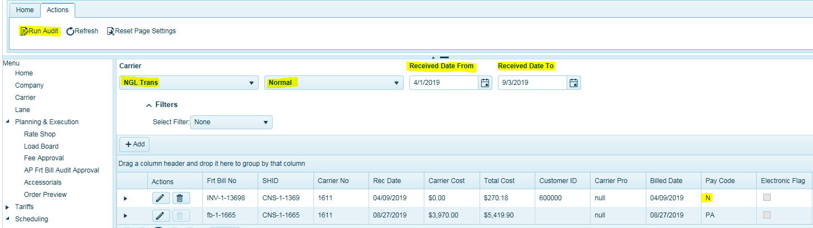
In the Actions menu Click Run Audit.
Note, the system will audit all transactions in this screen.
If audit was successful, all (N, M, or PA) transactions will go to (AA) Auto Approved status and be removed from this filter of Normal and now can be viewed in Approved filter.
Users can expand the black arrow to view messages as to the reason why a transaction cannot be audited.
This example below is showing a message that this transaction is pending approval (PA) and cannot run through the audit. User must go to Fee Approval page and approve fee(s).
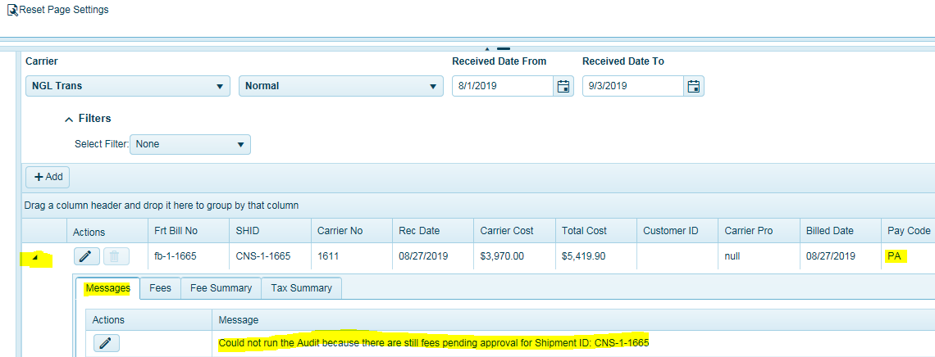

Matched (M)
To view all invoices that have matched a transaction in TMS and failed audit, select carrier and filter by Matched (M). All invoices that have failed audit and status of M will display here. Users must fix all M transactions and run the audit process manually so they can be approved and sent to the ERP for payment.
It is suggested to run the AUD075 – Load Audit Exception Report. This report will show all invoices that are in M status and need to be fixed by carrier. This report will show the difference between the expected cost and the billed cost.
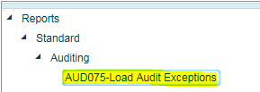
In most cases the failed audits will be related to a differential in the line haul cost, providing that you approved all fees. The Company level tolerance settings prevent higher than expected freight bills from passing audit. This setting can be found in the Desktop client, under each company called, Tolerances.
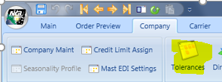
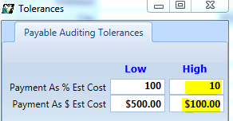
The values look at the % low and % high values and the $ dollar amount low and high values when auditing total cost of the invoices.
Above settings:
100% lower than billed cost to 10% above billed cost. If this is true, this passes this audit check.
$500 less than billed cost to $100 higher than billed cost. If this is true, this passes this audit check.
If either of these conditions fail, the freight bill will not pass audit. Both of these checks need to pass. If percentage passes but the dollar amount does not, it remains in M status and fails audit. These settings allow for freight invoices to pass due to minimal differential in pricing calculations.
If you set the % High to 0 and the dollar amount high to $0. This means the freight bill total cost needs to match or be lower in order to pass audit.
In order to approve and fix failed audits (M status) as a result of a higher than expected cost, users must go to the desktop client and add an Invoice Adjustment Fee. This assumes all fees have been approved.
Go to the desktop client and click on Find.
Expand Load in the Find section.
Search by ShipID or Freight Bill Number. Click and highlight either one, place your cursor in the field and hit enter. User can also search by order number (Maybe warehouse shipment number depending on your ERP configuration.)
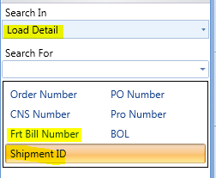
Go to the Revenue tab.
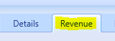
If the Lock All Costs box is checked, users must uncheck this box to insert Invoice Adjustment Fee.

In the Ribbon Bar, click on Icon with Plus Sign to open up the fees table.
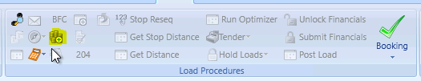
Search for the fee Invoice Adjustment, insert the difference in the total freight bill cost in the Minimum field. Click Save. The system will recalculate the total cost. Re-check the Lock All Cost field.
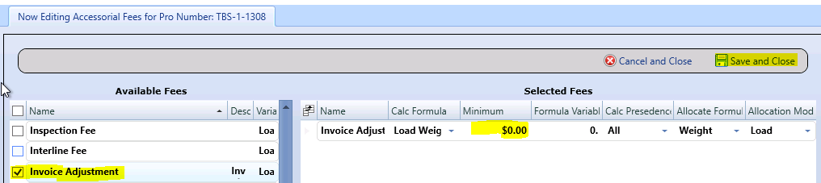
The next step is to Run the Audit function.
Go to the AP Freight Bill Audit Approval Page in the Web Client.
Select the appropriate carrier, apply your filter to Normal (or Electronic for EDI carriers) and insert the date range of the invoice your auditing. Once applied, you should see the transaction in the table.
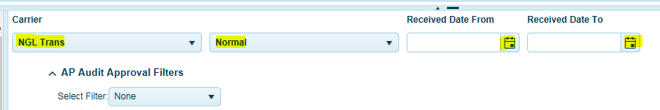
Click and highlight the transaction.
In the Actions menu, Click Run Audit.
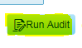
The system will update the records and perform the audit routine for this transaction or any other transactions that maybe on this screen. If Approved, the record(s) should remove from this filter and can be found in the APPROVED section.
Apply your filter to see APPROVED invoices and you should see the invoice is now approved.

Pending Approval
To view all pending approval invoices, select carrier and filter by Pending Approval (PA). All invoices that are waiting for fee approval will display here. User must approve fees in the Fee Approval page before the audit process can run.
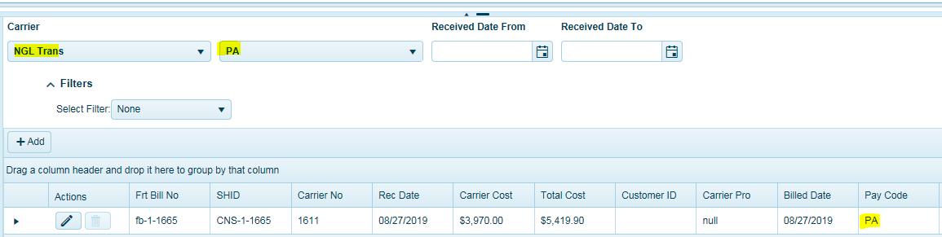

Approved Invoices
To view all approved freight invoices, select a carrier.
Enter in Invoiced Date Received date range.
All approved invoices will appear with a status of AA.
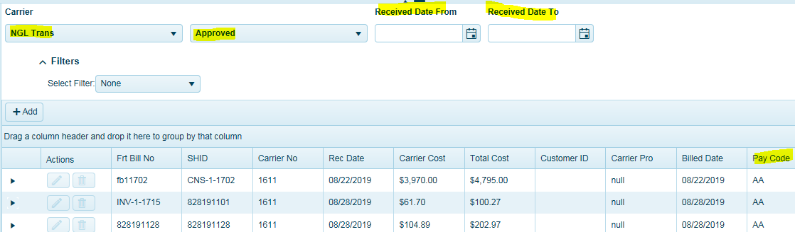
To see the fees that were approved for this invoice, highlight a row.
Expand the black arrow.
Click on Fees.
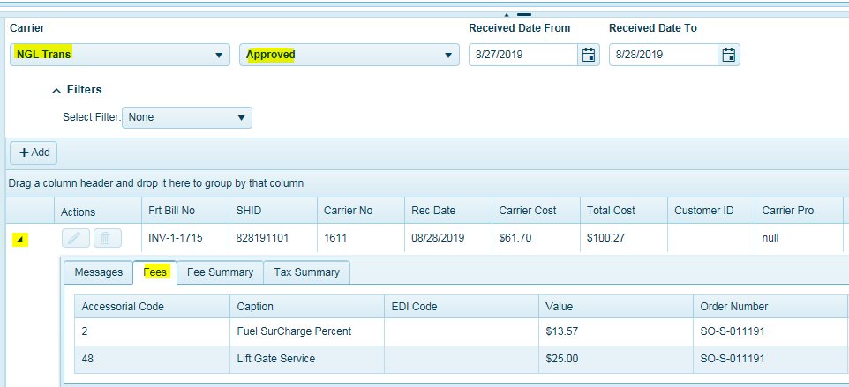
Click on Fees Summary tab to see summary of fees.

Auditing Report
Users can run the Audit report to view any transactions that remain in M status. These transactions are outstanding invoices that have yet to pass audit and should be reviewed and fixed.
Go to Reports
Expand Standard
Expand Auditing.
